**Question 1**

What is meant by the term “opportunity cost”? What is an example of an opportunity cost of going on a holiday?

**Answer:**The Opportunity Cost of a given action is the value of the next best alternative to that particular action.

The Opportunity Cost of a given action is the value of the next best alternative to that particular action. Suppose that instead of going a holiday, you would have worked at your summer job. In that case, you are giving up both the direct cost of the holiday (the costs of airfare, hotel, etc.) as well as the income you would have earned by working. These are both examples of opportunity costs.

**Question 2**

Karen’s friends have invited her to see a movie the following weekend. Karen has a job at a fast food restaurant and can earn $50 working there during the time she would be at the movie. She can also babysit for a neighbor for $60 on the same day. If the movie ticket costs $15, and bus ride to the theatre costs $4, what is Karen’s opportunity cost of going to the movie?

**Answer:**-15-4-60=-79

The opportunity cost of an action is the value of the next best alternative. In this case, Karen’s next best alternative is to babysit. Because this option is more valuable to her than working at the restaurant, we can ignore the latter option (as well as all other possible activities). By babysitting, Karen earns $60 and also gets to keep the $19 ($15 for the ticket plus $4 for the bus) that she would have spent going to the movie. Thus, her total opportunity cost of going to the movie is $79.

**Question 3**

Answer the following questions regarding the production possibilities curve (PPC):

1. What is the definition of a PPC?
2. Explain how the PPC illustrates the concept of opportunity cost.
3. Draw a typical PPC representing production possibilities for two goods. Label examples of points on your graph that are i.) attainable but inefficient, ii.) unattainable, and iii.) efficient.

D. Give an example of a change that will cause the PPC to shift out for both goods and an example of a change that will cause the slope of the PPC to change.

**Answer:**

1. the PPC captures all maximum output possibilities for two (or more) goods, given a set of inputs (or resources — in our case time) if all the available inputs are used.

A PPC is a curve that represents all of the maximum output possibilities for two or more goods, given a set of inputs (or resources - i.e., time), and given that those inputs are used efficiently.

1. OC=slope of the PPC

Because it represents the maximum output possibilities, the PPC makes clear that in order to produce more of one thing, we must produce less of something else. The slope of the PPC tells us the opportunity cost of an extra unit of a good because it tells us how much less of one good can be produced in order for one more unit of the other good to be produced.

(Note that the slope of the PPC is negative – i.e., a PPC is always downward sloping. This is because producing more of one thing always means that there are fewer resources available to produce something else. This means that the opportunity cost of producing more of one good is positive.)

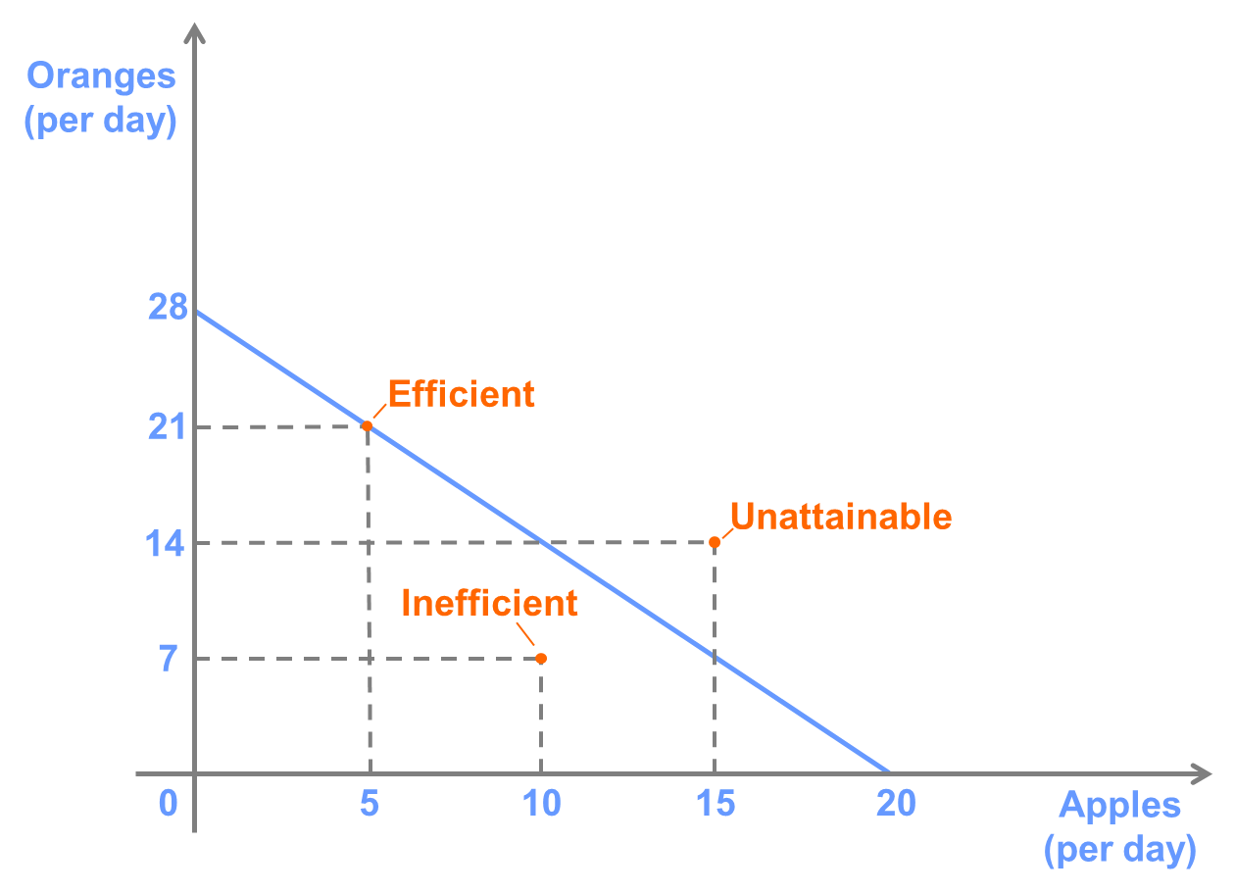

D. In the PPC drawn in part C, a season of particularly good weather would cause both apple and orange trees to produce more fruit, making it easier to pick both types of fruit and shifting out the PPC for both goods. A fungus that infects apple trees and causes them to produce less fruit will cause a change in the slope of the PPC. In particular, it will cause the opportunity cost of apples to increase.

**Question 4**

Suppose Alberto has the following PPC:

Assuming Alberto can work for 8 hours per day, show how each of the following changes would affect the PPC:

A. Alberto becomes more agile and can now catch 1.25 kg of rabbits per hour.

B. The banana trees grow taller, and Alberto needs 2 hours to collect 1 kg of bananas.

C. Alberto catches a cold and can only work 6 hours per day.

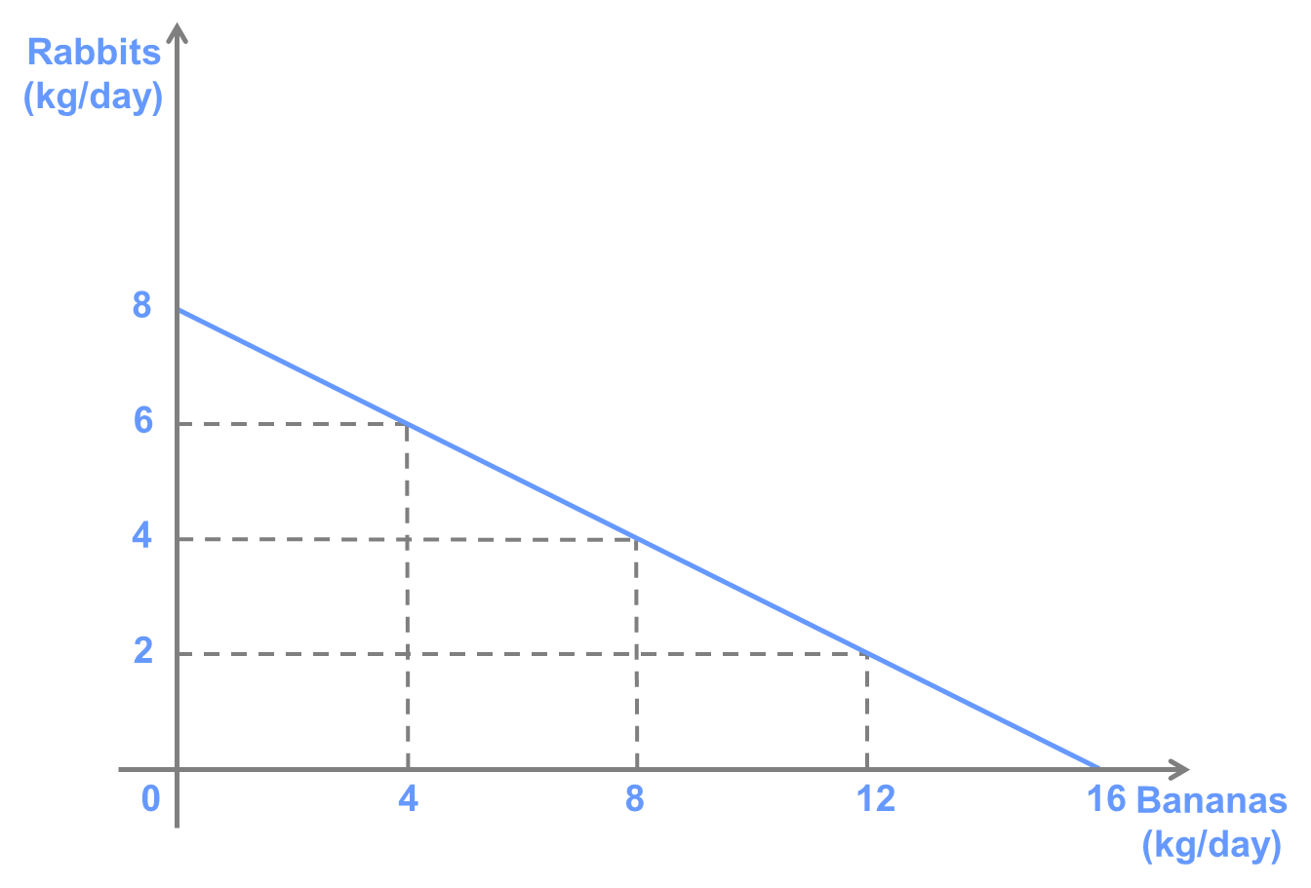

**Answer:**

1. The slope of the PPC will be added,he will get more rabbits

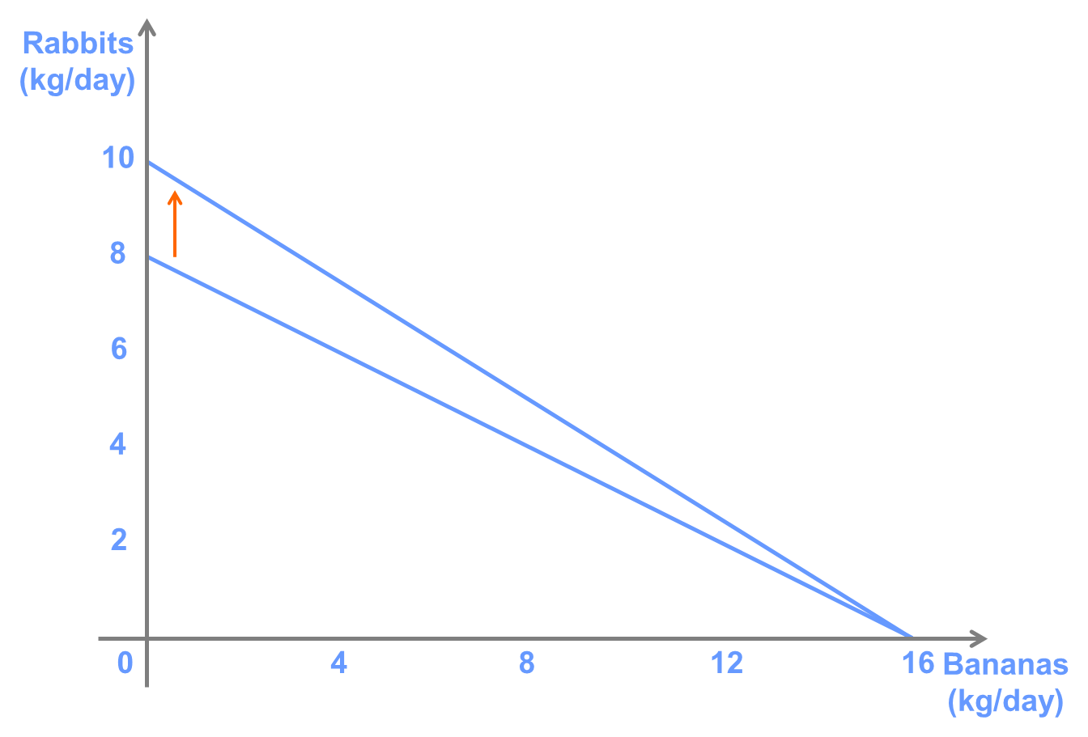

1. The slope of the PPC will be increased,he will get quarter bananas

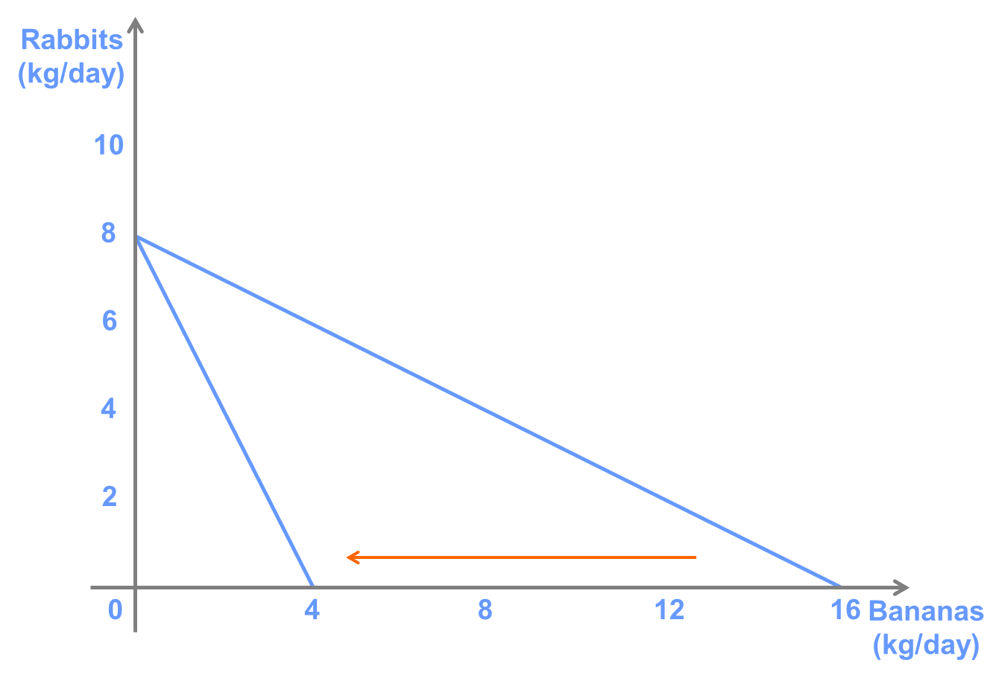

1. The slope of the PPC will not change,but he will get less bananas and rabbits

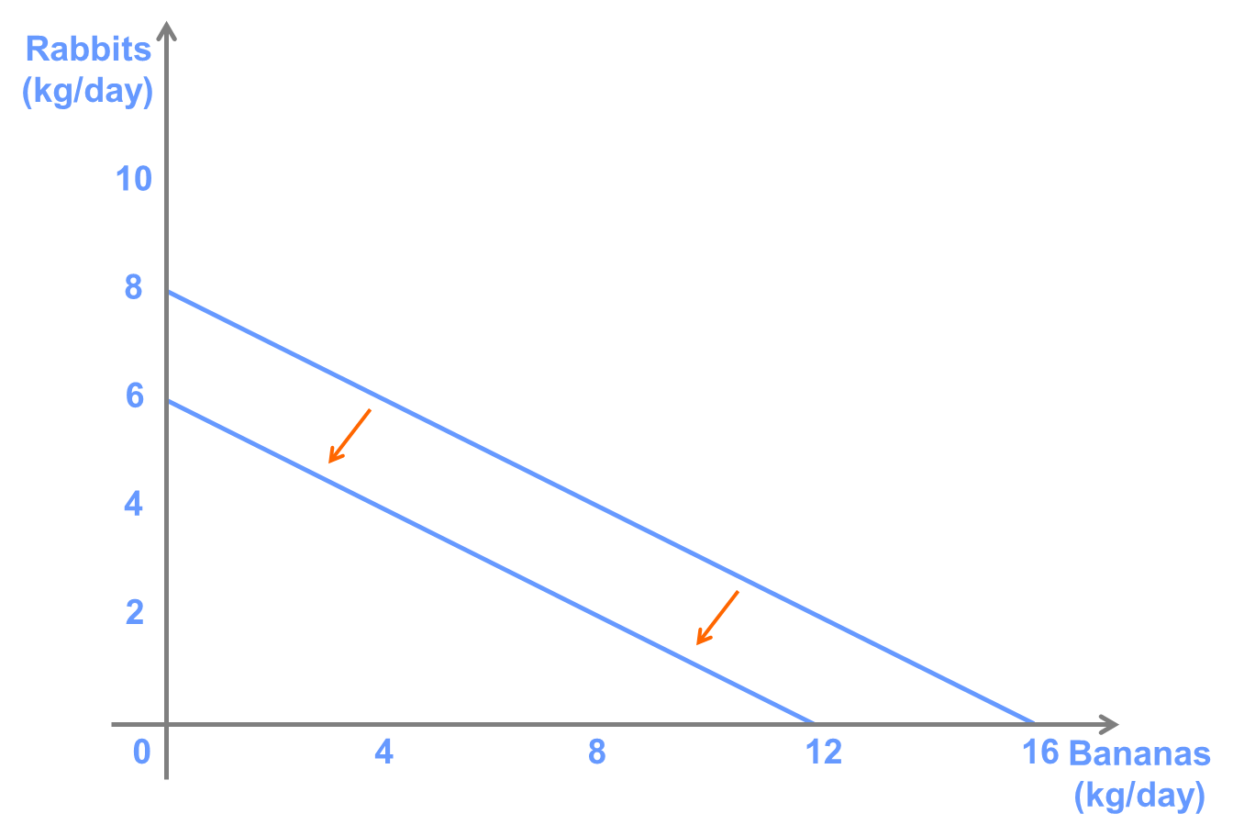

**Question 5**

Suppose that Steven can produce papayas and mangoes. He produces 4 kg of papayas per hour and 6 kg of mangoes per hour.

A. Draw Steven’s PPC, assuming that he has 8 working hours per day to divide between papaya and mango production.

B. Suppose that Steven takes a two-hour siesta instead of using all of his working hours to produce papayas or mangoes. Draw and label Steven’s production possibilities in this case.

C. Assume that Steven will produce 8 kg of papayas regardless of whether he takes a siesta. In this case, what is Steven’s opportunity cost of taking the siesta.

**Answer:**

A.

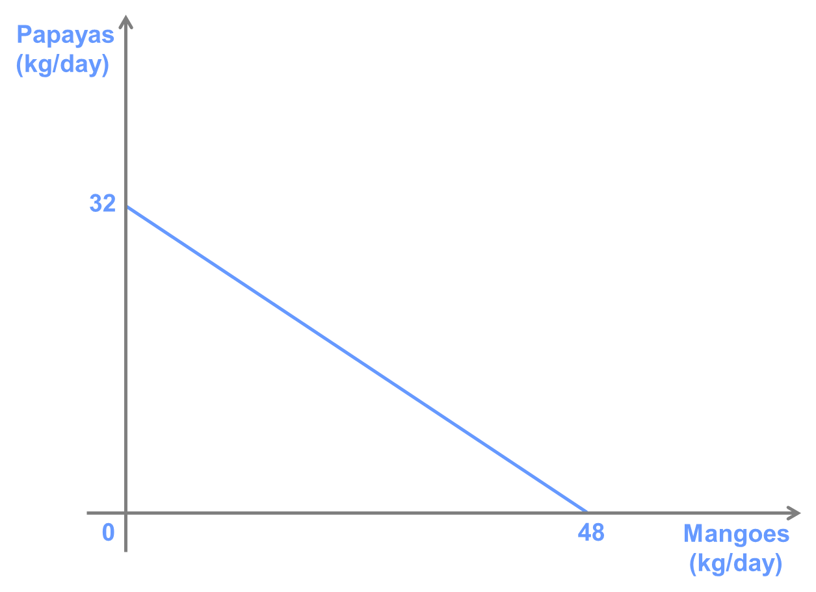

B.

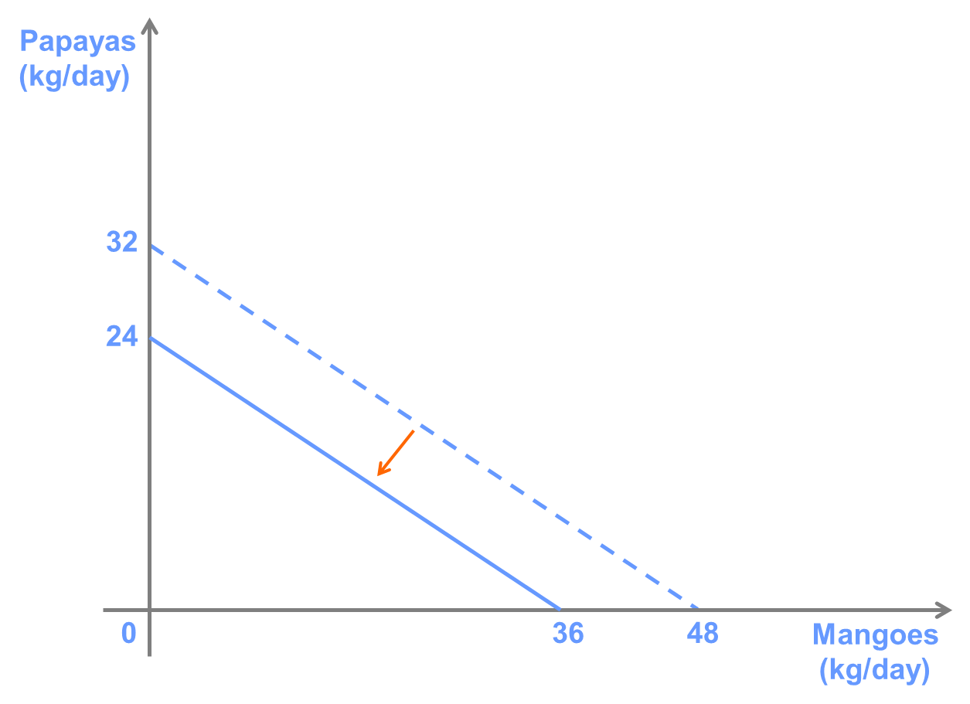

C.12 mangoes

2 hours 8 papayas

6 hours 36 mangoes

4 hours 24 mangoes

If Steven will produce 8 kg of papayas regardless of whether he takes a siesta, then the siesta will reduce the amount of mangoes he is able to produce. Thus, the opportunity cost of the siesta is 12 kg of mangoes (2 hours x 6 kg of mangoes/hour).

**Question 6**

Consider the following PPC for a tailor:

A. If the tailor works 8 hours per day, how many shirts can she produce per hour?

B. What is the tailor’s opportunity cost of producing shirts in terms of trousers?

C. Suppose the tailor can sell shirts for $20 each and trousers for $30 each. What is her opportunity cost of taking two hours off to see a movie if the cost of the movie ticket is $15?

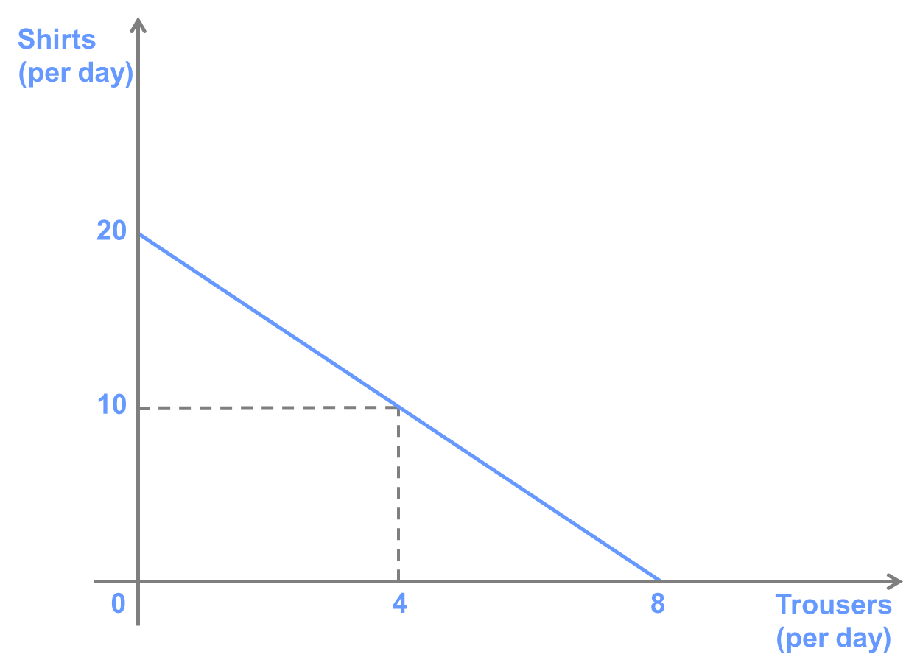

**Answer:**

A. 20/8=2.5 shirts/day 8/20=0.4 trousers/day

The tailor can produce 2.5 shirts/hour (20 shirts per day / 8 hours per day).

B.OC=2.5

The opportunity cost of a shirt is 0.4 trousers. To compute this, first we must find the slope of the PPC, which is equal to -20/8 = -2.5. This tells us that the tailor must give up producing 2.5 shirts for every additional pair of trousers she produces. Producing one more shirt requires giving up 1/2.5 = 0.4 pairs of trousers.

C.OC=100-(-15)=115

The tailor can earn $50/hour producing shirts ($20 x 2.5 shirts/hour) or $30/hour producing trousers ($30 x 1 pair of trousers/hour). Thus, producing shirts is her next best alternative. Since the movie takes 2 hours, she is giving up $100 in earnings. Thus, the total opportunity cost of seeing the movie is $115 ($100 in forgone earnings + $15 for the movie ticket).

**Question 7**

Suppose that Joshua spends 10 hours per day picking fruit. He can pick one kilogram of apples per hour and one kilogram of cherries every 2.5 hours.

A. What is Joshua’s opportunity cost of apples in terms of cherries?

B. At his local farmer’s market, Joshua can buy or sell as much fruit as he wants. If the price of apples is $4/kg, and the price of cherries is $8/kg, how many of each fruit will Joshua pick?

C. At the same prices, what is the greatest amount of cherries that Joshua can consume? What is the greatest amount of apples?

D. At what prices would he be willing to pick both types of fruit?

**Answer:**

1. OC apple=4/10=0.4 cherries
2. apples=10,cherries=0
3. cherries=5,apples=10
4. cherry=$10/kg,apple=$4/kg

A.

In the time it takes to pick one kilogram of apples, Joshua could produce 1/2.5 = 0.4 kg of cherries.

B.

In the market, the price of apples in terms of cherries is $4/$8 = 0.5 kg of cherries per kg of apples. Thus, Joshua’s opportunity cost of picking apples is less than their price (in terms of cherries) in the market, so he should specialize in picking apples. Thus, he will produce 10 kg of apples and 0 kg of cherries.

C.

Since Joshua is best off specializing in picking apples, the most apples he can consume are the 10 kg that he picks. Alternatively, he can trade all of his apples for 5 kg of cherries. It is easy to check that if Joshua instead decided to specialize in producing cherries, the most he could produce is 4 kg of cherries, which he could trade for at most 8 kg of apples, so he is clearly better off by obeying the principle of comparative advantage!

D.

If the price of apples in terms of cherries in the market were exactly the same as Joshua’s opportunity cost of picking apples, then there would be no benefit to Joshua of specializing in picking either apples or cherries. Thus, for any set of prices for which (price of apples)/(price of cherries) = 0.4, he will be equally well off picking any combination of apples and cherries along his PPC.

**Question 8**

In a two-person economy, Brian can produce at most 6 cups or 18 saucers per day, while Candice can produce at most 8 cups or 12 saucers per day. If Brian and Candice work together, which of the following combinations of cups and saucers are attainable? Which are efficient?

A. 8 cups and 10 saucers

B. 10 cups and 12 saucers

C. 16 cups and 0 saucers

D. 14 cups and 6 saucers

**Answer:**

A attainable B efficient

CD unattainable

**Question 9**

George and Martha can produce Mangoes and Bananas. The table lists the number of each that they can produce per hour.

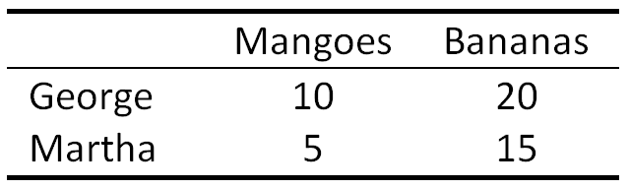

A. Who has an absolute advantage in producing Mangoes? Bananas?

B. What is the opportunity cost for George of Mangoes in terms of bananas?

C. Who has a comparative advantage in producing Mangoes?

D. Suppose that George always wants to eat 5 Mangoes and spends 2 hours per day picking fruit. If he only consumes fruit he has picked himself, what is the largest number of Bananas he could eat? What if he trades with Martha?

**Answer:**

1. George,George
2. OC(mangoes)=20/10=2 bananas
3. George
4. 30 bananas,45 bananas

A.

George has an absolute advantage in producing both Mangoes and Bananas.

B.

George’s opportunity cost of Mangoes is 2 Bananas. This is because producing an extra Mango requires 1/10 hours, during which time, he could have produced 2 Mangoes (20/10).

C.

Martha’s opportunity cost of producing Mangoes is 3 Bananas. Therefore, George has a comparative advantage in producing Mangoes because his opportunity cost is lower.

D.

If George produces 5 Mangoes, he has 1.5 hours left to produce Bananas, so he could eat 30 Bananas if he only eats fruit he has picked himself. However, Martha should be willing to trade Bananas for Mangoes at any rate less than her opportunity cost of producing Mangoes. The best George could do would be if Martha agreed to trade 3 Bananas for 1 Mango (i.e., the point at which she is equally well off trading Bananas for Mangoes as for producing Mangoes herself.) In this case, George could produce 20 Mangoes and trade 15 Mangoes to Martha in exchange for 45 Bananas.

**Question 10**

Suppose there are two countries that can each produce two goods, lumber and wool. The opportunity cost of a tonne of lumber in Country A is 50 kg of wool and the opportunity cost of a tonne of lumber in country B is 300 kg of wool.

A. Which country has a comparative advantage in producing wool?

B. Suppose that Country A can produce 500 tonnes of lumber per year, and Country B can produce 100 tonnes of lumber per year. Which country has an absolute advantage in producing wool?

**Answer:**

1. country B
2. Country B

A.

Country B has a comparative advantage in producing wool. This is because Country B has a lower opportunity of producing wool (1/300 tonnes of lumber per kg) than Country A (1/50 tonnes of lumber per kg).

B.

Country B has an absolute advantage in producing wool. They can produce 30,000 kg of wool per year (100×300 kg) compared to country A, which can produce 25,000 kg of wool per year (500×50 kg).

**Question 11**

Consider the PPCs of Larry and Moe depicted below. Suppose that each wants to consume both bread and cheese.

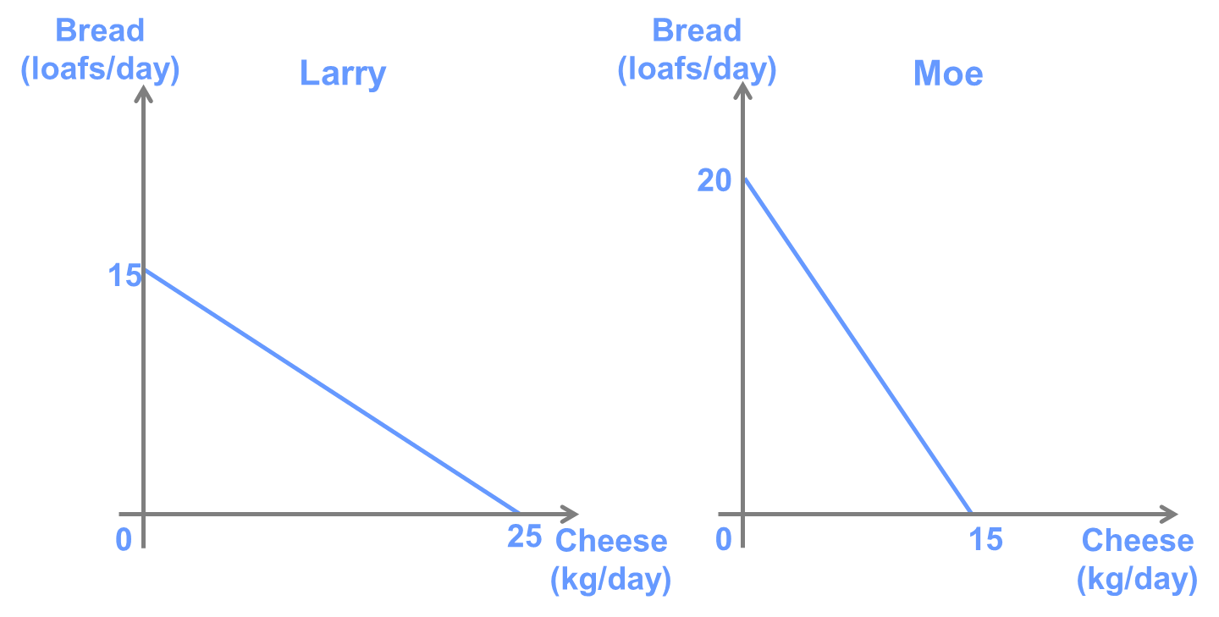

If Larry and Moe decide to specialize and trade with one another,

A. Who has an absolute advantage in producing bread?

B. Who has a comparative advantage in producing bread?

C. Suppose that Moe produces 5 kg of cheese. How much of each good should Larry be producing if Larry and Moe are experiencing the maximum gains from specialisation?

Answer:

1. Moe
2. Moe

C.bread

35

(25,20)

0 40 cheese

Larry 25 cheeses?

Since Moe has a comparative advantage in producing bread, he should only produce cheese once Larry has reached the maximum amount of cheese he can produce. Therefore, Larry must be producing 25 kg of cheese and 0 loaves of bread.

**Question 12**

Suppose that Hamish and Harold can produce either tables or chairs at a constant rate per hour.

A. Draw Hamish’s PPC, given that his opportunity cost of one table is 1/3 chairs and that he can produce a maximum of 3 tables in 8 hours of work.

B. Draw Harold’s PPC, given that his opportunity cost of one table is 3 chairs, and he can produce a maximum of 1 table in 8 hours.

C. Suppose that Hamish and Harold decide to exchange tables and chairs at a price of one table for one chair. Draw the consumption possibilities curves for each person.

D. What is the largest number of chairs Hamish can obtain per day?

E. What is the largest number of chairs Hamish could obtain if he did not trade with Harold?

**Answer:**

A.chair B. chair

3

1

0 1 3 table 0 1 3 table

D.3 chairs E.1chair

**Question 13**

The following table shows the output an identical set of workers can produce per month in Australia and Brazil.

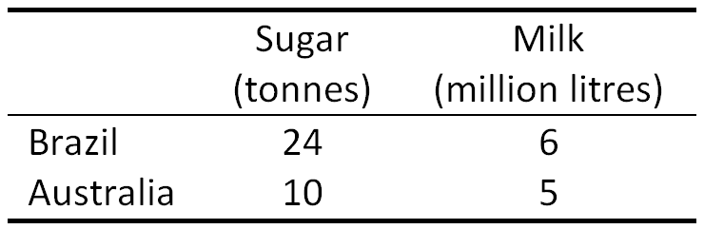

What is the range of prices for a million litres of milk in terms of tonnes of sugar for which the countries will be willing to trade with one another?

**Answer:**

OC(s) OC(m)

B 1/4 4

A 1/2 2

Australia needs price more than 2s for m

Brazil needs price less than 4s for m

Between this price

The opportunity cost of a million litres of milk in Brazil is 4 tonnes of sugar. In Australia, the opportunity cost is 2 tonnes of sugar. Thus, the price of a million litres of milk must be between 2 and 4 tonnes of sugar in order for the countries to trade.

Since Australia has a comparative advantage in milk, it will specialise in producing milk and trade some of its milk for Brazilian sugar. If the price of milk is below 2 tonnes of sugar, Australia will be better off producing its own sugar, and if the price is above 4 tonnes of sugar, Brazil will be better off producing its own milk.

**Question 14**

Consider a many-person economy, populated by workers who have different relative abilities to produce two goods, X and Y.

A. Draw an example of the economy-wide PPC for such an economy.

B. Label two points that represent efficient levels of production. Explain how the opportunity cost of producing an extra unit of X is different at these two points.

C. Using this example, explain how a “bow-shaped” PPC illustrates the Low-Hanging Fruit Principle.

**Answer:**

As we produce more X the OC of X increases

A.

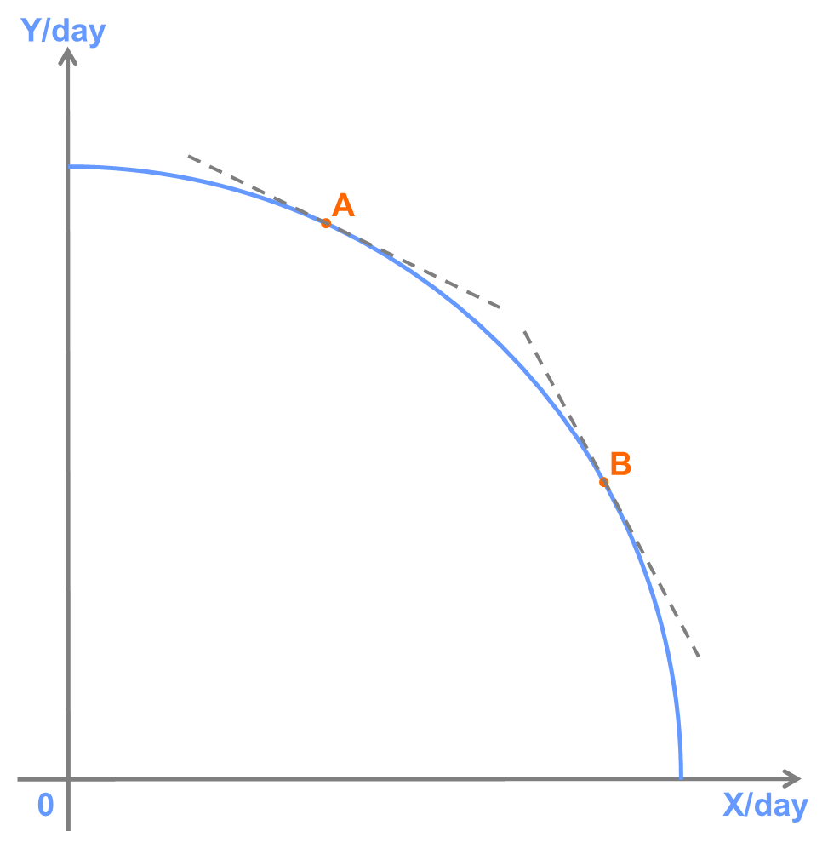

B.

The slope of the PPC is greater (steeper) at point B than point A. This indicates that the opportunity cost of producing good X is greater at point B than point A because it implies that producing one more unit of X requires giving up a larger amount of Y at point B. In general, the opportunity cost of producing either good is increasing as more of it is produced.

C.

This is a result of the Low-Hanging Fruit Principle because it is a result of the resources (in this case, workers) with the lowest opportunity cost being employed first in the production of each unit of each good. So, for example, as more X is produced, it requires the use of workers who are relatively better at producing Y to be used, requiring more units of Y to be forgone in producing a unit of X.